.EFFECT OF PLYOMETRIC TRAINING WITH YOGIC PRACTICES ON SPEED AND AGILITY AMONG VOLLEYBALL ADOLESCENT PLAYERS

Mr. Prahlad Singh Patel, Research Scholar
M.G.C.G.V. Chitrakoot, Satna (M.P.)
Prof. Leons Wilfred Vaz, Professor
L.N.I.P.E. Gwalior (M.P.)
Dr. Shrikrishna Patel ^{(*)}, I/C Principal
D.A.V. Training College, Kanpur (U.P.)
Abstract
- The purpose of this study will be to discover Effect of plyometric training programme with yogic practices on speed and agility of adolescence volleyball players. 45 adolescent volleyball male players with the age ranged from fourteen to twenty years. All the subjects residing at own home and during training were imparted within the Sports and Youth Welfare Department, Academy, Narsinghpur, M.P. For this study two Motor Fitness Components namely speed and agility were used. This study was conducted to determine possible cause and effect relationship of 08 weeks Plyometric training and yogic practice on volleyball players. To analyze data, descriptive statistics was used. Further to check the effectiveness of each training program between pre and post test in both experimental group paired t- test was used.To make adjustments for difference in the initial means and test the adjusted posttest means for significant differences, the analysis of covariance (ANCOVA) was used (Broota, 1989) and the hypothesis was tested at 0.05 level of significance. The findings of the study in relation tospeed and agility, subject showed in a significant difference between pre and post test in ploymetric training and ploymetric& yogic asana training group. There was significant difference among different training group in relation to speed and agility. Further, In case of post means difference ploymetric& yogic exercise training group and control group was found insignificant difference, in relation to speed and ploymetric training and ploymetric& yogic exercise training group was found insignificant difference, in relation to agility.
Keywords:Plyometric, Adolescent, Explosive Strength, Muscular Endurance

INTRODUCTION
Modern volleyball require for player a good physical stamina, parallel it is very important to develop speed and explosive power and force endurance. Volleyball is also a social game, where next to the good coordination and cleverness comes up to the important place team players good rapprochement and cooperation
Plyometric exercises have been shown to improve jump performance in many sports. These exercises combine strength with speed of movement to produce power. By using the myotatic stretch reflex of the muscle to produce an explosive reaction, plyometric is believed to be the link between speed and strength (Powers, 1996). The plyometric method is ranked among the most frequently used methods for conditioning in volleyball. In the present study training methods include plyometric training; plyometric training with yogic practices will be used.
METHODOLOGY
Purpose:The purpose of this study will be to discover Effect of plyometric training programme with yogic practices on speed and agility of adolescence volleyball players.
Selection of Participants:Forty five adolescent volleyball male players and all of them were purposively selected as subjects for the study. The age level of subjects ranged from fourteen to twenty years. All the subjects residing at own home and during training were imparted within the KhelAvamYuvaKalyanVibhag, Academy, Narshinghpur.
Selection of Variables
For this study the following Motor fitness variable was chosen:
- Motor Fitness Components
- Speed
- Agility
Classifications of Groups
A pre and posttest control group design was employed for this investigation In this study, groups were classified into three. They are as follows:

Group-I | Experimental Group ‘A’(Plyometric training group)
Group-II | Experimental Group ‘B’(Plyometric training combined with yogic practice)
Group-III | Control group
Administration of Tests
The research scholar put in the maximum effort and meticulous care to attain precision and accuracy in the measurements. Sophisticated instruments and standard procedures were used to assess the performance on different variables.
50-Yard dash
Test objective – to measure speed.
Equipments – stopwatches, with a split second time.
Administration and directions – two lines are marked on the floor 50 yards apart. One line is used as a starting line and the other as the finish line. On the signal ready? Go! The subjects start running at their best to reach the finish line at their earliest. The signal ‘Go’ is accompanied with the downward sweep of the starter’s arm to give the visual signal to the timers who stand at the finish line.
Scoring – the interval between the starting signal and the instant subject crosses the finish line is the score of the test. The time is recorded correct up to tenth of a second.
Shuttle Run
Test objective – To measure agility while running and changing directions
Equipments – stopwatch, measuring tape, marking tape, and two blocks of wood (2× 2× 4’’)
Administration and directions – lines are placed 30 feet apart with marking tape. The two blocks are placed adjacent to and outside of the line not being used as the starting line. On the signal “Go” the test performer (1) runs from the starting line to the blocks and picks one up; (2) returns to the starting line and places the block behind the line’; (3) runs to pick up the second block; and (4) returns to the starting line and places the second block behind the line.
Scoring – two trials are permitted. The better time to the nearest one-tenth second is accepted as the score. Rest should be allowed between trials.
RESULTS AND DISCUSSION
TABLE – 1.1
Significance of difference between Pre and Post Test Performance of Plyomertic Training Group in Speed
Groups | Mean | SD | SE Mean | DM | SE Mean Diff. | “t” ratio
Pre test | 8.91 | 1.14 | .295 | .540 | .138 | 3.90*
Post test | 8.37 | .790 | .204 | .540 | .138 | 3.90*
*Significant at 0.05 level, t_{.05}(14) = 2.145
TABLE – 1.2
Significance of difference between Pre and Post Test Performance of Plyometric and Yogasana Training Group in Speed
Groups | Mean | SD | SE Mean | DM | SE Mean Diff. | “t” ratio
Pre test | 8.21 | .801 | .207 | .147 | .117 | 1.25
Post test | 8.36 | .901 | .232 | .147 | .117 | 1.25
*Significant at 0.05 level, t_{.05}(14) = 2.145

Table 1.3

Descriptive Statistics of adjusted post Mean Speed of Treatment groups in Volleyball Players
Group | Mean | Std. Error | 95% Confidence Interval
Group | Mean | Std. Error | Lower Bound | Upper Bound
plyometric training | 8.092(a) | .099 | 7.893 | 8.291
plyometric &yogasana training | 8.616(a) | .098 | 8.417 | 8.814
control group | 8.639(a) | .096 | 8.445 | 8.833

Table 1.4

Analysis of Covariance for between subject effect among Experimental groups
Source | Type III Sum of Squares | df | Mean Square | F | Sig.
Group | 2.662 | 2 | 1.331 | 9.60* | .000
Error | 5.681 | 41 | .139
Total | 3240.160 | 45
Corrected Total | 27.892 | 44

Table 1.5

Pair wise comparison of Mean Speed with Least Significant Difference among Treatment groups
(I) Group | (J) Group | Mean Difference (I-J) | Std. Error | Sig. | 95% Confidence Interval for Difference^{b}
 |  |  |  |  | Lower Bound | Upper Bound
Plyometric Training Group | Plyometric &Yogasana Exercise Group | -.524(*) | .143 | .001 | -.812 | -.524(*)
Plyometric Training Group | Control Group | -.547(*) | .138 | .000 | -.826 | -.547(*)
Plyometric &Yogasana Exercise Group | Control Group | -.023 | .137 | .866 | -.300 | -.023

TABLE 1.6
Least Significant Difference Post Hoc Test of the Mean of Speed at Different Methods of Training in Volleyball Player
Plyometric Training  Group | plyometric &yogasana training Group | Control  Group | MD | CD at 5%  level
8.092 | 8.616 |  | .524(*) | .275
8.092 |  | 8.639 | .547(*) | .275
 | 8.616 | 8.639 | .023 | .275
*significant at 0.05 level
Table 1.6 revealed that there is significant difference between the paired mean of Speed at different methods of training at plyometric training and plyometric &yogasana training is .524, plyometric training and control group is .547, plyometric &yogasana training and control group is .023 respectively. The highest significant paired mean difference was recorded between plyometric training and control group is .547, on the other hand the lowest significant paired mean difference was recorded between plyometric &yogasana training and control group is .023. The graphical representation of mean of Speed at different methods of training has been presented in Figure 1.

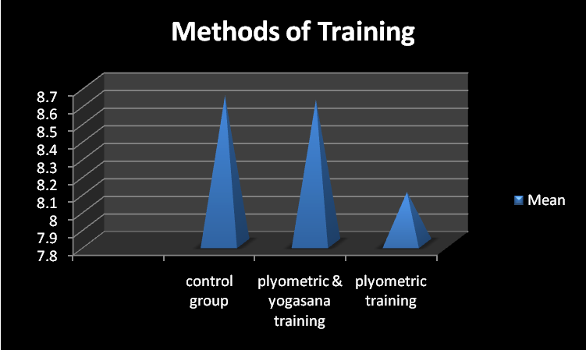
Figure 1- Mean comparison of Speed at different methods of training
TABLE – 2.1
Significance of difference between Pre and Post Test Performance of Plyomertic Training Group in Agility
Groups | Mean | SD | SE Mean | DM | SE Mean Diff. | “t” ratio
Pre test | 11.15 | 1.07 | .276 | .36 | .067 | 5.392*
Post test | 10.79 | .974 | .251 | .36 | .067 | 5.392*
*Significant at 0.05 level, t_{.05}(14) = 2.145

TABLE –2.2
Significance of difference between Pre and Post Test Performance of Plyometric and Yogasana Training Group in Agility
Groups | Mean | SD | SE Mean | DM | SE Mean Diff. | “t” ratio
Pre test | 10.56 | .585 | .151 | .373 | .041 | 9.153*
Post test | 10.19 | .570 | .147 | .373 | .041 | 9.153*
*Significant at 0.05 level
t_{.05}(14) = 2.042

Table - 2.3

Descriptive Statistics of adjusted post Mean Agility of Treatment groups in Volleyball Players

Group | Mean | Std. Error | 95% Confidence Interval
Group | Mean | Std. Error | Lower Bound | Upper Bound
plyometric training | 10.429(a) | .053 | 10.323 | 10.536
plyometric &yogasana training | 10.388(a) | .052 | 10.283 | 10.492
control group | 10.810(a) | .052 | 10.706 | 10.914

Table- 2.4

Analysis of Covariance for between subject effect among Experimental groups

Source | Type III Sum of Squares | Df | Mean Square | F | Sig.
Group | 1.607 | 2 | .803 | 20.33* | .000
Error | 1.620 | 41 | .040
Total | 5037.480 | 45
Corrected Total | 36.250 | 44

Table- 2.5

Pair wise comparison of Mean Agility with Least Significant Difference among Treatment groups

(I) Group | (J) Group | Mean Difference (I-J) | Std. Error | Sig. | 95% Confidence Interval for Difference^{b}
 |  |  |  |  | Lower Bound | Upper Bound
Plyometric Training Group | Plyometric &Yogasana Exercise Group | .042 | .075 | .581 | -.110 | .194
Plyometric Training Group | Control Group | .380(*) | .075 | .000 | -.532 | -.229
Plyometric &Yogasana Exercise Group | Control Group | .422(*) | .073 | .000 | -.569 | -.276

TABLE- 2.6
Least Significant Difference Post Hoc Test of the Mean of Agility at different Methods of training in Volleyball Player
Plyometric Training  Group | plyometric &yogasana training Group | Control  Group | MD | CD at 5%  level
10.429 | 10.388 |  | .042 | .147
10.429 |  | 10.810 | .380(*) | .147
 | 10.388 | 10.810 | .422(*) | .147
*significant at 0.05 level
Table 2.6 revealed that there is significant difference between the paired mean of Agility at different methods of training at plyometric training and plyometric &yogasanatraining is .042, plyometric training and control group is .380, plyometric &yogasana training and control group is .422 respectively. The highest significant paired mean difference was recorded between plyometric &yogasana training and control group is .422, on the other hand the lowest significant paired mean difference was recorded between plyometric training and control group is .042. The graphical representation of mean of Agility at different methods of training has been presented in Figure 2.

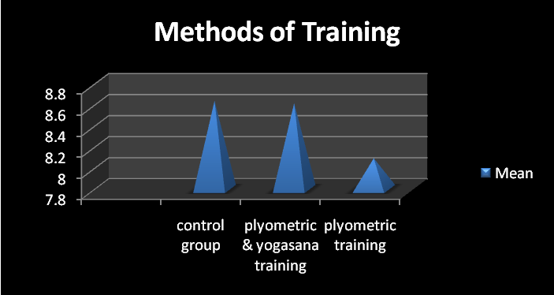
Figure 2- Mean comparison of Agility at different methods of training

Findings of the study
- In case of speed, subject showed in a significant difference between pre and post test in ploymetric training group and no significant difference in ploymetric& yogic asana training group.
- There was significant difference among different training group in volleyball players.
- In case of post means difference of ploymetric training group and ploymetric& yogic exercise training group ploymetric training group and control group was found significant whereas ploymetric& yogic exercise training group and control group was found insignificant difference, in relation to speed.
- In agility, subject showed in a significant difference between pre and post test in ploymetric training and ploymetric& yogic asana training group.
- There was significant difference among different training group in relation to shuttle run.
- In case of post means difference of ploymetric training group and control group and ploymetric& yogic exercise training group and control group was found significant. andploymetric training and ploymetric& yogic exercise training group was found insignificant difference, in relation to agility.
REFRENCES
Clark H. Harison. Application of Measurement in Health & Physical Education.(Newjersy, AngelwoolcliftsPrentic Hall Publication), 1976.
Devinder K. Test and measurement in Sports and Physical Education, (New Delhi, D.V.S.) ,1996.
Chelly, Mohamed Souhaiel., Effects of in-Season Short-Term Plyometric Training Program on Leg Power, Jump- and Sprint Performance of Soccer Players, Journal of Strength and Conditioning Research: October 2010 - Volume 24 - Issue 10 - p 2670-2676
H. Thomas Ford, Jr., John R. Puckett& James P. Drummond, Effects of Three Combinations of Plyometric and Weight Training Programs on Selected Physical Fitness Test Items, First Published June 1, 1983 Research Article
Ilyararay, S &Sakthigananvel, D, Effect of combination of speed and plyometric training on speed and agility”, International research Journal of Health Fitness and sports science, 1(2), 52-65.
KagithaVaraprasadaRao& Kumar P.P.S. Paul, Effect of Complex Training with Yogic Practices on Selected Motor Fitness Variables and Playing Ability Among Kabaddi Men Players, International Journal of Humanities and Social Science Invention, Volume 2 Issue 10. 2013.
Kagitha, V. R. & Kumar, P.P.S.P, Effect of complex training with yogic practices on selected motor fitness variables and playing ability among Kabaddi men players, International Journal of Humanities and social science invention,2(10), 2319-7714.

