A Comparative study of Anxiety between Sports Persons and Non-Sports Persons

Dr. Vijay Prakash
Assistant Professor
Noida College of Physical Education
JNV Road, Near Dadri, G.B Nagar
Email- vijayrai34@yahoo.com
Abstract
The purpose of the study was to assess and compare Anxiety between Sports Persons and Non-Sports Persons. For the purpose of the study, total 300 subjects will be selected in two groups i.e. 150 in sports persons (Individual Games-50, Combative Games-50, Team Games-50) and 150 Non-sports Persons i.e. (I.T.-50, A.G.-50, B.Sc.-50) were selected randomly on the basis of stratified random sampling. The subjects were selected from Banaras Hindu University and Mahatma Gandhi Kashi Vidyapith respectively. (Subjects of Institute of Technology (I.T) were selected from Banaras Hindu University only.) The age level of the subjects ranged from 18 to 25 years. Keeping the feasibility criterion in mind, the Anxiety variable was selected for the present study. Anxiety (State/Trait Anxiety) was assessed with the help of State Trait Anxiety Inventory (STAI) developed by Charles D. Spielberger, Richard L. Gorusch, and Robert E. Lushene. To assess and compare the level of Anxiety between sports persons and non-sports persons, Descriptive Statistics i.e. mean, standard deviation, t test, analysis of variance (ANOVA) were used. The level of significance was set as 0.05 level. Significant difference was found between sports persons and non-sports persons in relation to Anxiety. Anxiety of Non-Sports Persons was found to be more than that of the Sports Persons. Significant difference was found among Individual, Team and Combative Game Players in relation to Anxiety. The observed sequence of performance was found Team > Combative > Individual in relation to Anxiety. Insignificant difference was found among I.T, A.G and B.Sc. Students in relation to Anxiety.
Key words: Anxiety, Sports Persons, Non-sports Persons.

Affiliation- Department of physical Education, NCPE.

PROLOGUE
Anxiety is a psychological and physiological state characterized by somatic, emotional, cognitive and behavioral components (Seligman, M. E. P ., Walker, E. F. & Rosenhan, D. L. 1982).
Anxiety is a generalized mood condition that can often occur without an identifiable triggering stimulus. As such, it is distinguished from fear, which is an emotional response to a perceived threat. Additionally, fear is related to the specific behaviors of escape and avoidance, whereas anxiety is related to situations perceived as uncontrollable or unavoidable (Ohman, A. 2000).
Anxiety sets in when an individual begins to doubt his or her capacity to deal with the situation which builds stress. Quite often it is not the talent that decides your performance. It simply depends on the way you deal with the ups and downs of the game. According to 'Athletic Insight', a journal of sports psychology, anxiety can be classified in two ways; trait anxiety and state anxiety. State anxiety is situational stress induced by situations in the game. A sportsperson's autonomic nervous system is aroused in this state which is the natural reaction of any individual. On the other hand, trait anxiety can be thought of as a world view that an individual uses when coping with stress. In sports, individuals who are state anxious and low on the trait anxiety in tough situations, often deliver good performances consistently (Prashant, M. 2009).
Anxiety is not only a behavioural phenomenon. Characteristic autonomic changes take place, typically including increased heart rate and/or blood pressure. There is also marked endocrine activation, particularly increased secretion of the adrenal hormones adrenaline noradrenaline and cortisol (the ‘stress’ hormone). There has been much discussion of how far these ‘peripheral’ events can actually induce emotional states such as anxiety, or are part of the body's response to those states.
Anxiety does not only consist of physical effects; there are many emotional ones as well. They include “feelings of apprehension or dread, trouble concentrating, feeling tense or jumpy, anticipating the worst, irritability, restlessness, watching (and waiting) for signs (occurrences) of danger, and, feeling like your mind's gone blank” as well as nightmares/bad dreams, obsessions about sensations, a trapped in your mind feeling, and feeling like everything is scary (Smith, M. 2008).
The Spielberger’s State-Trait Anxiety Inventory (STAI) has been widely used for estimating anxiety. In STAI, state anxiety is an emotional state consisting of fear or apprehension while trait anxiety refers to a predisposition to perceive situations as potentially threatening. In similar dynamic, we speculated that anxious athletes with distorted perception would be more sensitive and irritable in competitive arenas (Spielberger, C. D. 1966).
This differentiated the two types of anxiety as state anxiety and trait anxiety. According to him state anxiety refers to situational anxiety or the tendency to become fearful only in a specific situation. State anxiety may vary in intensity and fluctuate over time. State anxiety is a temporary condition caused by one’s immediate perception of the environment whereas trait anxiety is a relatively stable individual difference in anxiety proneness. During the past century, however, many dedicated and gifted behavioral scientists, physiologists, and psychologists have focused their energies on human motivation (Speilberger, C. D., Gorsuch R. L. & Lushane, R. E. 1970).
Objective of the study
  - To assess and compare the anxiety between sports persons and non-sports persons.
  - To assess and compare the anxiety among Individual, Combative and Team Game Players.
  - To assess and compare the anxiety among I.T, A.G and B.Sc. Students.
Hypothesis
1. There will not be any significant difference between Sports Persons and Non-Sports Persons in relation to Anxiety.
2. There will not be any significant difference among Individual, Combative and Team Game Players in relation to Anxiety.
3. There will not be any significant difference among I.T, A.G and B.Sc. Students in relation to Anxiety.
Procedure and Methodology

Selection of subjects
To achieve this purpose of investigation, a total 300 Male Subjects (150 Sports Persons & 150 Non-Sports Persons) were selected randomly on the basis of stratified random sampling. The subjects were selected from Banaras Hindu University and Mahatma Gandhi Kashi Vidyapith respectively. (Subjects of Institute of Technology (I.T) were selected from Banaras Hindu University only.) The age level of the subjects ranged from 18 to 25 years. The distribution of the subjects has been numerated below in table no. 1.
Table-1
Details of the Subjects Distribution with regard to Sports Persons and Non-Sports Persons
Category of Subjects | Sub Category of Subjects | Number of Subjects
Sports Persons | Individual Games | 50
Sports Persons | Combative Games | 50
Sports Persons | Team Games | 50
Non-Sports Persons | Institute of Technology (I.T.) | 50
Non-Sports Persons | Agriculture Sciences (A.G.) | 50
Non-Sports Persons | Faculty of Sciences (B.Sc.) | 50

Selection of Variables
Keeping the feasibility criterion in mind, the anxiety variable was selected for the present study.

Criterion Measures
Anxiety (State/Trait Anxiety) was assessed with the help of State Trait Anxiety Inventory (STAI) developed by Charles D. Spielberger, Richard L. Gorusch, and Robert E. Lushene.
Statistical technique

Descriptive Statistics i.e. mean, standard deviation, t test, analysis of variance (ANOVA) was used. The level of significance was set as 0.05 level.

Result of the Study
The findings pertaining to descriptive statistics, t test, one way analysis of variance (ANOVA) as well as post hoc test for the various psychological variables of one hundred and fifty Sports Persons and one hundred and fifty Non-Sports Persons have been presented in table no. from 2 to 8.
Table-2
Descriptive Statistics of Sports Persons and Non-Sports Persons in relation to Anxiety
Sports Persons |  | Non-Sports Persons
Mean | 71.90 | Mean | 82.62
Standard Error | 1.56 | Standard Error | 1.54
Median | 71 | Median | 80
Mode | 69 | Mode | 74
Standard Deviation | 19.12 | Standard Deviation | 18.86
Sample Variance | 365.60 | Sample Variance | 355.89
Kurtosis | -0.33 | Kurtosis | 4.86
Skewness | -0.01 | Skewness | 1.43
Range | 89 | Range | 134
Minimum | 27 | Minimum | 48
Maximum | 116 | Maximum | 182
Sum | 10786 | Sum | 12394
Count | 150 | Count | 150
It is evident from table - 2 that mean and standard deviation scores of Sports Persons and Non-Sports Persons in relation to Anxiety has been found 71.90 & 82.62 and 19.12 & 18.86 respectively and range of score was 89 & 134 respectively where as standard error was found 1.56 & 1.54 respectively.
Table-3
Comparison of Anxiety between Sports Persons & Non-Sports Persons
Groups |  |  |  | T-ratio
Sports Persons |  | Non-Sports Persons |  | 4.88*
Mean | S.D | Mean | S.D | 4.88*
71.90 | 19.12 | 82.62 | 18.86 | 4.88*
* Significant at 0.05 level of significance
T-value required to be significant at 298 df = 1.97
Table-3 revealed that significant difference was found between Sports Persons & Non-Sports Persons in relation to Anxiety, since T-value of 4.88 was found greater than the required tabulated value of 1.97 with 298 df at 0.05 level of significant.
Non-Sports Persons possessed greater Anxiety in comparison to Sports Persons.

The graphical representation of means between Sports Persons and Non-Sports Persons in relation to Anxiety has been presented in figure No.1.
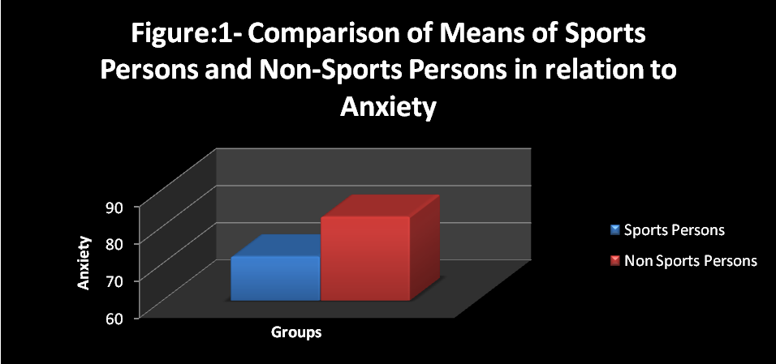
Table-4
Descriptive Statistics among Individual, Team and Combative Game Players in relation to Anxiety
Individual Game |  | Team Game |  | Combative Game
Mean | 62.3 | Mean | 84.46 | Mean | 68.96
Standard Error | 2.49 | Standard Error | 2.22 | Standard Error | 2.41
Median | 64.5 | Median | 84 | Median | 68.5
Mode | 69 | Mode | 69 | Mode | 49
Standard Deviation | 17.62 | Standard Deviation | 15.71 | Standard Deviation | 17.04
Sample Variance | 310.5 | Sample Variance | 246.82 | Sample Variance | 290.56
Kurtosis | -0.50 | Kurtosis | -0.85 | Kurtosis | -0.60
Skewness | 0.07 | Skewness | 0.34 | Skewness | -0.19
Range | 70 | Range | 56 | Range | 72
Minimum | 29 | Minimum | 60 | Minimum | 27
Maximum | 99 | Maximum | 116 | Maximum | 99
Sum | 3115 | Sum | 4223 | Sum | 3448
Count | 50 | Count | 50 | Count | 50
It is evident from table - 4 that mean and standard deviation scores among Individual, Team and Combative Game Players in relation to Anxiety has been found 62.3, 84.46 & 68.96 and 17.62, 15.71 & 17.04 respectively and range of score was 70, 56 & 72 respectively where as standard error was found 2.49, 2.22 & 2.41 respectively.
Table-5
Analysis of Variance among Individual, Team and Combative Game Players in relation to Anxiety
Source of Variation | Sum of Squares | df | Mean Square | F-Value | Sig.
Between Groups | 12927.85 | 2 | 6463.92 | 22.87* | .00
Within Groups | 41546.84 | 147 | 282.63 | 22.87* | .00
* Significant at 0.05 level of significance
F 0.05 (2, 147) = 3.06
Table- 5 revealed that there was significant difference among Individual, Team and Combative Game Players in relation to Anxiety, as obtained F-ratio was 22.87, which was higher than the tabulated value 3.06, required for F-ratio to be significant at 0.05 level with (2,147) degree of freedom.
Since the one way analysis of variance was found significant in relation to Anxiety, the least significant difference (LSD) test was applied to find out the differences of the paired means among Individual, Team and Combative Game Players.

Table-6
Least Significant Difference (LSD) post hoc test for the paired means among Individual, Team and Combative Game Players in relation to Anxiety
Means |  |  | Sig. | Mean Difference | Critical Difference
Individual | Team | Combative | Sig. | Mean Difference | Critical Difference
62.30 | 84.46 |  | .00 | -22.16(*) | 6.58
62.30 |  | 68.96 | .049 | -6.66(*) | 6.58
 | 84.46 | 68.96 | .00 | 15.50(*) | 6.58
* Significant at 0.05 level of significance
It is evident from table- 6 that paired mean differences among Individual, Team and Combative Game Players in relation to Anxiety was found significant between Individual and Team; Individual and Combative; Team and Combative.
The graphical representation of means among Individual, Team and Combative Game Players in relation to Anxiety has been presented in figure No.2.
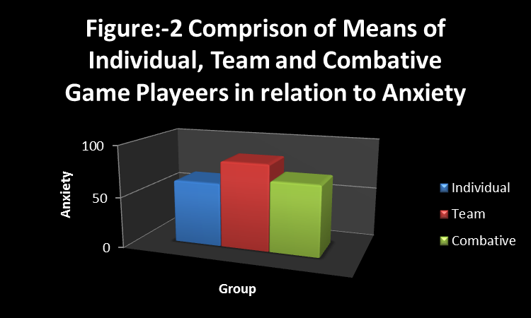
Table-7
Descriptive Statistics among I.T, A.G and B.Sc. Students in relation to Anxiety
I.T Student |  | A.G Student |  | B.Sc. Student
Mean | 86.84 | Mean | 81.9 | Mean | 79.14
Standard Error | 3.39 | Standard Error | 2.46 | Standard Error | 1.85
Median | 83.5 | Median | 77 | Median | 79.5
Mode | 63 | Mode | 77 | Mode | 67
Standard Deviation | 23.97 | Standard Deviation | 17.45 | Standard Deviation | 13.10
Sample Variance | 574.74 | Sample Variance | 304.62 | Sample Variance | 171.79
Kurtosis | 4.25 | Kurtosis | 0.35 | Kurtosis | -0.34
Skewness | 1.51 | Skewness | 0.60 | Skewness | 0.43
Range | 134 | Range | 83 | Range | 52
Minimum | 48 | Minimum | 50 | Minimum | 58
Maximum | 182 | Maximum | 133 | Maximum | 110
Sum | 4342 | Sum | 4095 | Sum | 3957
Count | 50 | Count | 50 | Count | 50
It is evident from table - 7 that mean and standard deviation scores among I.T, A.G and B.Sc. Students in relation to Anxiety has been found 86.84, 81.9 & 79.14 and 23.97 , 17.45 & 13.10 respectively and range of score was 134, 83 & 52 respectively where as standard error was found 3.39, 2.46 & 1.85 respectively.
Table-8
Analysis of Variance among I.T, A.G and B.Sc. Students in relation to Anxiety
Source of Variation | Sum of Squares | df | Mean Square | F-Value | Sig.
Between Groups | 1521.85 | 2 | 760.92 | 2.17* | .118
Within Groups | 51507.23 | 147 | 350.38 | 2.17* | .118
*Insignificant at 0.05 level of significance
F 0.05 (2, 147) = 3.06
Table- 8 revealed that there was insignificant difference among I.T, A.G and B.Sc. Students in relation to Anxiety, as obtained F-ratio was 2.17, which was lower than the tabulated value 3.06, required for F-ratio to be significant at 0.05 level with (2,147) degree of freedom.
Since the one way analysis of variance was found insignificant in relation to Anxiety the least significant difference (LSD) test was not applied to find out the differences of the means among I.T, A.G and B.Sc. Students.
The graphical representation of means among I.T, A.G and B.Sc. Students in relation to Anxiety has been presented in figure No.3.
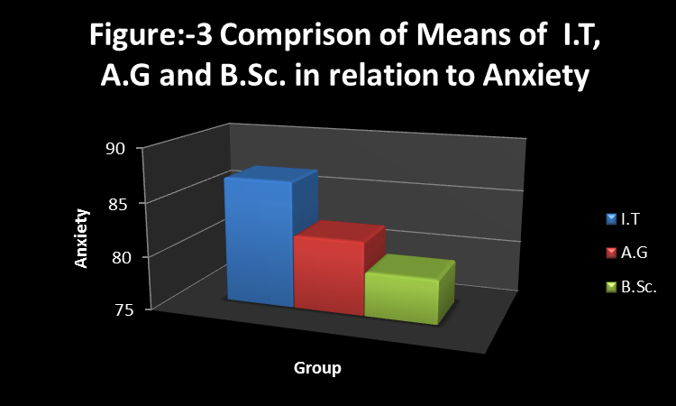

Discussion of findings
From the findings of the study it was evident that the significant difference was found between Sports Persons and Non-Sports Persons whereas Non-Sports Persons possessed greater Anxiety in comparison to Sports Persons. The findings may be attributed to the fact that Anxiety refers to the state of restlessness and agitation, often with general indisposition and a distressing sense of oppression at the epigastria. Non-Sports Persons were selected from I.T, A.G and B.Sc. Students as per the selection process of the courses and the subjects chosen by the candidates. It has been observed that usually those who have academically bright career and are of competitive nature often choose it profession the demand of today as grades go down the rest preferences come because they have high sense of achievements and they want to excel in their respective fields and their competitive nature might have increased the score of anxiety whereas the Sports Persons those who have already achieved at the university and state level have already learned to control their State Anxiety which is an integral part of our assessment whereas Trait Anxiety cannot be change much.
Dutta, A. K. (1984) conducted a study on topic “Investigation of selected Physical, Physiological and Psychological assessments as predications in Hockey Performance”. In the present study on 14 male Hockey Players in the age group of 18-24 years it is concluded that low level of Anxiety contributes to superior performance. The result of the study supports the present study.
Dyrbye, L. N., Thomas, M. R. & Shanafelt, T. D. (2006) in their study concluded that high prevalence of Anxiety among Medical Students than general population was due to personal and training-related features, however currently available information is insufficient to draw firm conclusions. In the present study a high level of Depression between Sports Persons in comparison to Non-Sports Persons might be due to personal and training features.
Kiluk, D. B., Weden, S. & Culotta, P. V. (2009) conducted a study on topic “Sport participation and Anxiety in children” and concluded that active sport participation may be associated with a reduced expression of Anxiety.
Singh, R. (1988) conducted a study on topic “Comparison of Anxiety level between champion and non-champion male and female Judo Players of national level”. In the present study the author compared the Anxiety of champions and non-champions and concluded that champions possessed low level of Anxiety than the non-champions. The result of the study supports the present study.
In case of Sports Persons, if we compare the Anxiety among Individual, Team and Combative Games Players it may be concluded that significant difference was found among Individual, Team and Combative Games Players and the observed sequence of performance was found Team > Combative > Individual in relation to Anxiety. This may be attributed to the fact that in Team Games the success and failure depends on the Team Performance. Even if an Individual is having the higher ability the success cannot be ascertained because results came out with the collective efforts whereas in Individual and Combative Games the success and failure depends on the Individual Performance.
In case of Non-Sports Persons, if we compare the Anxiety among I.T, A.G and B.Sc. Students it may be concluded that insignificant difference was found among I.T, A.G and B.Sc. Students. This may be attributed to the fact that I.T Students are academically more bright career and more competitive, often choose it as profession as is the demand of today as grades go down the rest preferences come because they have high sense of achievement and they want to excel in their respective field and their competitive nature might have increased the score of Anxiety in comparison to A.G and B.Sc. Students.
Discussion of Hypothesis
1. The hypothesis, that there will be no significant difference between Sports Persons and Non-Sports Persons in relation to Anxiety is rejected since significant difference was found between Sports Persons and Non-Sports Persons in relation to Anxiety.
2. The hypothesis that, there will be no significant difference among Individual, Combative & Team Game Players in relation to Anxiety is rejected since significant difference was found among Individual, Combative & Team Game Players in relation to Anxiety.
3. The hypothesis that, there will be no significant difference among I.T, A.G and B.Sc. Students in relation to Anxiety is accepted since no significant difference was found among I.T, A.G and B.Sc. Students in relation to Anxiety.
Conclusions
1. Significant difference was found between the Anxiety of Sports Persons & Non-Sports Persons.
2. Anxiety of Non-Sports Persons was found to be more than that of the Sports Persons.
3. Significant difference was found among Individual, Team and Combative Game Players in relation to Anxiety.
4. The observed sequence of performance was found Team > Combative > Individual in relation to Anxiety.
5. Insignificant difference was found among I.T, A.G and B.Sc. Students in relation to Anxiety.

REFERENCES
Books
Alderman, R. B. (1974). Psychological Behaviour in Sport. Philadelphia: W.B. Sounders Company.
Barlow, D. H. (2002). Unraveling the Mysteries of Anxiety and its Disorders from the Perspective of Emotion Theory. U. S. A: Prentice Hall.
Ohman, A. (2000). Fear and Anxiety: Evolutionary, Cognitive, and Clinical Perspectives. New York: The Guilford Press.
Seligman, M. E. P., Walker, E .F. & Rosenhan, D. L. (1982). Abnormal Psychology. New York: W.W. Norton & Company, Inc.
Spielberger, C. D. (1966). Theory and Research on Anxiety in Anxiety and Behavior. Ed: Spielberger New York: Academic Press.
Speilberger, C. D., Gorsuch R. L. & Lushane, R. E. (1970). Manual for the State-Trait Anxiety Inventory. California: Consulting Psychologists Press.
Journals and Periodical
Andressa, S., Sandra, S., Ciro, W., Roberto, V., Ronnie, A., Vander, F., Sergio, T. & Marco, T. (2010). Sleep Quality Evaluation, Chronotype, Sleepiness and Anxiety of Paralympic Brazilian Athletes: Beijing 2008 Paralympic Games. British Journal Sports Medicine, 123(3), 264-266.
Altshuler, L. L., Hendrich, V. & Cohen, L. S. (1998). Course of Mood and Anxiety Disorders during Pregnancy and the Postpartum Period. Journal of Clinical Psychiatry, 59(29), 34-43.

Beekman, A. T., De, B. E., Van, B. A., Deeg, D. J., Van-Dyck, R. & Van, T. W. (2000). Anxiety and Depression in Later Life: Co-Occurrence and Communality of Bartholomew, J. B., Morrison, D. & Ciccolo, J. T. (2005). Effects of Acute Exercise on Mood and Well-Being in Patients with Major Depressive Disorder. Journal of Medicine and Science in Sports and Exercise, 37(12), 2032-2037.

Dyrbye, L. N., Thomas, M. R. & Shanafelt, T. D. (2006). Systematic Review of Depression, Anxiety, and other Indicators of Psychological Distress among U.S. and Canadian Medical Students. Journal of Academic Medicine, 81(4), 354-373.
Kiluk, D. B., Weden, S. & Culotta, P. V. (2009). Sport Participation and Anxiety in Children with ADHD. Journal of Attention Disorders, 12(6), 499-506.
Singh, Rajinder. (1988). Comparison of Anxiety level between Champion and Non-Champion Male and Female Judo Players of National Level. Nis Scientific Journal, 11(1), 94-98.
Unpublished Thesis
Dutta, A. K. (1984). Investigation of Selected Physical, Physiological and Psychological Assessments as Predications in Hockey Performance. Unpublished Ph.D Thesis, Jiwaji University.
Website
Prashant, M. (2009). Performance Anxiety in Sports. Retrieved June 22, 2009, from http://www.buzzle.com/articles/performance-anxiety-in-sports.html
Smith, M. (2008). Anxiety Attacks and Disorders. Retrived on 3 March 2009, from http://www.helpguide.org/mental/anxiety_types_symptoms_treatment.htm>

