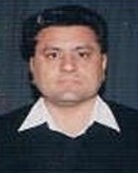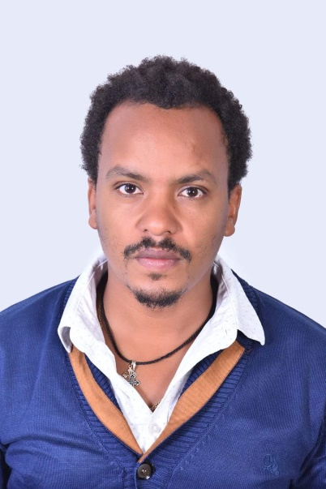

**Dr. Harish Kumar** **Assistant Professor** **Department of Sport Sciences Punjabi University Patiala batish09@yahoo.com**

**Ph.d Scholar**

**Anteneh Kumlachew**

**Department of Sport Sciences Punjabi University Patiala**

**Email: 21anteneh79@gmail.com**