RELATIONSHIP OF SELECTED ANTHROPOMETRIC AND KINEMATIC VARIABLES TO THE TECHNIQUE OF FRONT FOOT OFF- DRIVE IN CRICKET

Dr. Ratnesh Singh, Assistant Professor, Department of Physical Education, Visva-Bharati, Santiniketan, W.B.

Received on : 16 May 2012
Reviewed on : 19June 2012
Approved on : 10 July 2012

Abstract
The purpose of the study was to determine the relationship between selected anthropometric and kinematic variables to the technique of Front Foot-Off Drive in Cricket. Five (N=5) male cricket players who represented LNIPE, Gwalior in East Zone Inter University Cricket Tournament were selected as subjects for the study. Sequential photography technique was used to film the subjects. Joint Point Method was used in order to obtain the values of selected angular kinematic variables from developed stick figure. Height of Center of Gravity was calculated by segmentation method. To determine the degree of relationship between selected anthropometric and kinematic variables with the batting performance in front foot off- drive, Pearson’s Product Moment Correlation Method was used. The results have shown the significant values of coefficient of correlation at Right Hip Joint and Left Hip Joint at the moment stance and Left Knee Joint at the moment contact. Insignificant relationship was shown between the Height of Center of Gravity at the selected moment of the subjects in Front Foot-Off Drive.

Keywords: Kinematic Analysis, Back Lift, Front Foot Drive and Center of Gravity.

Introduction
Earlier studies have illustrated the biomechanical principles related to cricket batting and evaluated the effectiveness of coaching cues Davis (1983); Elliot et al. (1993); Stretch et al. (1995). However most of the studies have addressed the descriptive (kinematic and kinetic) aspects of the game. Gibson and Adams used a split-image filming technique to examine the time course of the batting action of an international batsman when facing a fast medium bowler and a bowling machine set at same velocity Gibson and Adams (1989). Since Drives are the basic strokes in cricket. The post-impact bat horizontal velocity for the drive was significantly greater than that for the forward defensive stroke where there is less of a follow-through, as it is a defensive stroke. Given that batting is such an important part of the game, it is surprising that little biomechanics research has been undertaken in this area of the sport. The biomechanics of the off-drive and on-drive have been found to be very similar, with only minor differences occurring in their execution. Batting in cricket is a quintessential example of a dynamic interceptive action in sport, and an ideal vehicle for studying interactions between perception and action (Stretch, Bartlett). The aim of the drive is to hit the ball with sufficient force to score runs, while still maintaining control of the ball (Stretch et al., 1998). The success of the stroke can be ascertained from the resultant end-point linear speeds and the interaction between bat and ball. Stretch et al. (1998) reported that, in the drive, which requires the ball to be hit with both power and accuracy. The post-impact bat horizontal velocity for the drive was significantly greater than that for the forward defensive stroke where there is less of a follow-through, as it is a defensive stroke.
Therefore, the Research Scholar felt worthwhile to investigate the Front Foot Off Drive Technique so that a good technique is determined and Coaches and Physical Education Teachers will be able to employ it for better performance. Hence, the purpose of this study was to identify the relationship of selected kinematic variables to the technique in Front Foot Off Drive.

Methods
The subjects for the present study were five (N=05) male cricket players from LNIPE, Gwalior. All subjects ranged between the chronological age of 18-24 years and were right handed batsman who participated in the West-Zone Intervarsity tournament for LNIPE, Gwalior. To determine the degree of relationship between selected kinematic variables with the batting performance of Front Foot Off Drive in Cricket, Pearson’s Product Moment Correlation Method was used.

Criterion Measures
The technique of Front Foot Off Drive in Cricket of each selected subjects were taken, as the criterion measures for the purpose of the present study. The technique was recorded on the basis of the following Criteria which is explained in Table-

Table-1
Evaluating Criteria of Front Foot Off Drive in Cricket
S. No Components Points
1. Stance 2
2. Back lift 2
3. Footwork 2
4. Downswing & Impact 2
5. Follow-through 2
Total 10

Procedure of Collection Data

The Technique of the Subjects, Filming protocol, analysis and the way anthropometric measurements obtained are described as under.

Technique of the Subjects
The technique of the subjects on Front Foot Off Drive in Cricket was collected on the basis of evaluation by three judges. The score of the judges were considered as the final points obtained by each batsman.

Collection of Data and Filming Protocol

The Sequential Photographic technique was employed for the kinematic analysis of Front Foot Off Drive in Cricket. A NIKON MODEL F-90 (with motor drive) camera was used for the purpose of the study. The camera was placed at a distance of 11 feet at Frontal Plane; the height of the camera (lenses) was fixed at a height of 1.17 metre from the ground. For obtaining individual sequential photography, the subjects were photographed in a controlled condition. The kinematic variables of the body were calculated at Moment Stance and Contact Point. The author developed stick figures on the photographs from which selected kinematic variables were calculated. The stick figures were developed by using Joint Point Method.

Procedure for Location of Center of Gravity
The Center of Gravity of the body at the moments was determined by segmentation method. This method was used to find the distance of the Center of Gravity of a body from some arbitrarily chosen line. This was done from a photograph which provided information concerning (a) weights of various parts or segments of the player’s body (arm, forearm, hand, thigh etc.) and (b) location of the center of gravity of these segments. The location of center of gravity of body segments is presented in Table-2:

Table-2
Location of Centre of Gravity of Body Segments
S.  NO | Segment | C.G location Expressed as percentage of  Total Distance Between Reference Point.
1 | Head | 46.4% to vertex; 53.6% to chin-neck intersect
2 | Trunk | 38% to suprasternal notch;62%to hip axis
3 | Upper Arm | 51.3% shoulder axis; 48.7% to elbow axis
4 | Fore Arm | 39% to elbow axis; 61% to wrist axis.
5 | Hand | 82% to wrist axis; 18% to knuckle three
6 | Thigh | 37.2% to hip[ axis; 62.8% to knee axis
7 | Calf | 37.1% to knee axis; 62.9% to ankle axis
8 | Foot | 44.9% to heel; 55.1% to hip of the longest toe

Photograph and Elegon of Various Moments of Subject 1
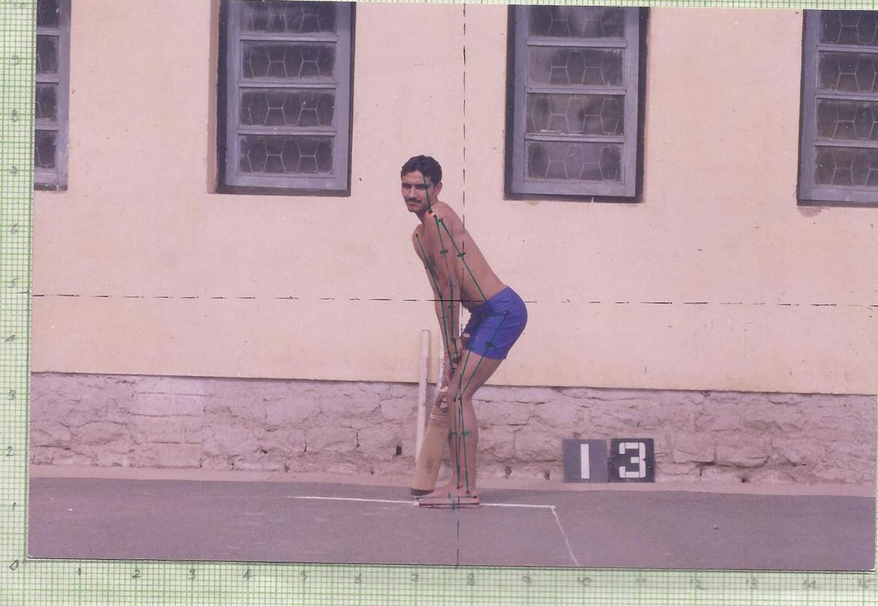
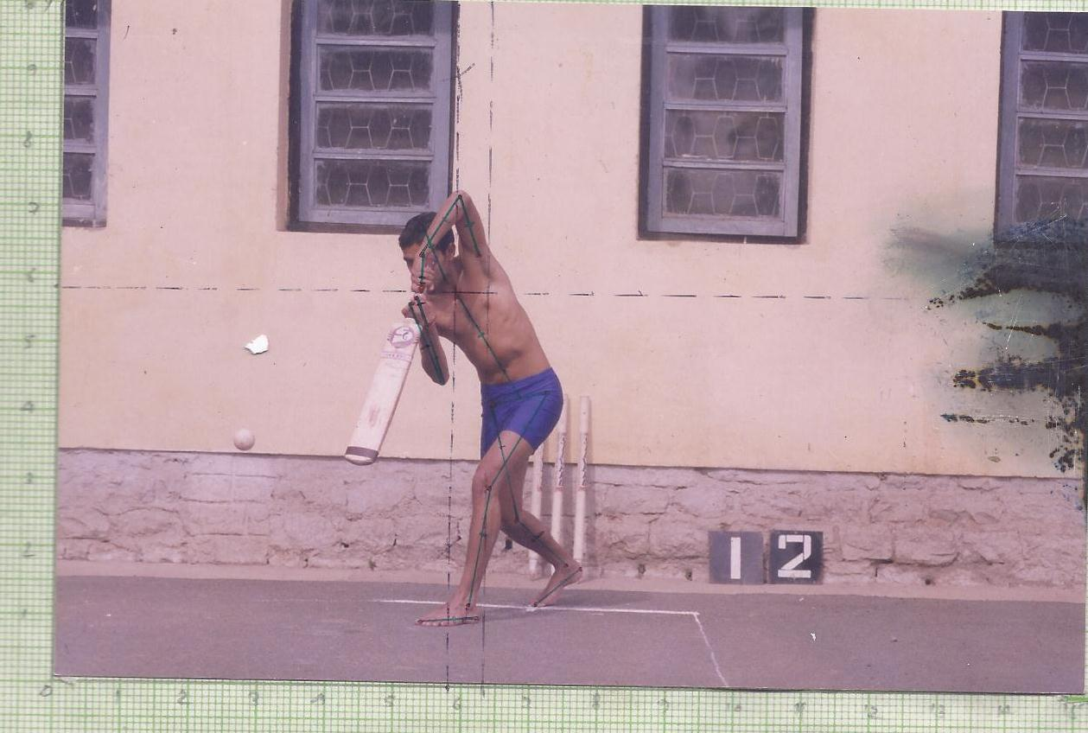
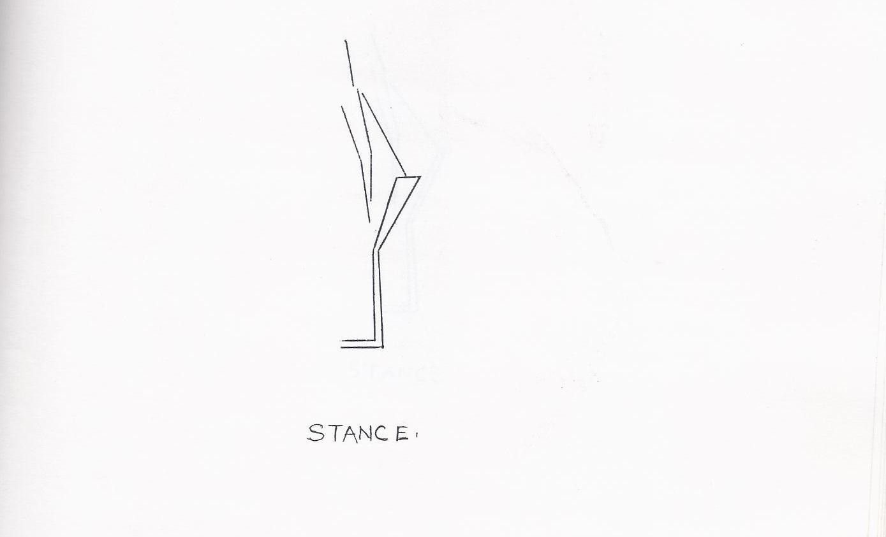
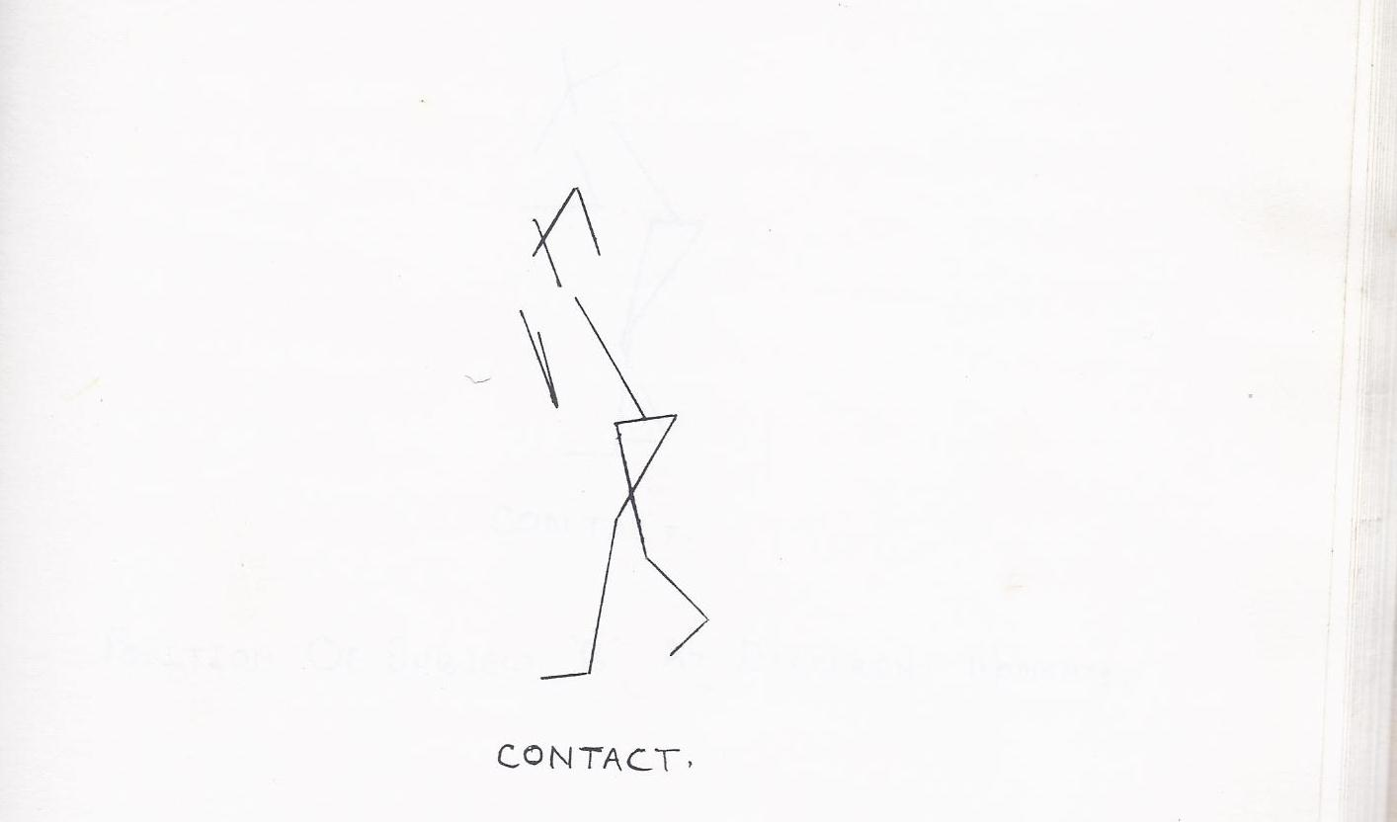

Photograph and Elegon of Various Moments of Subject 2

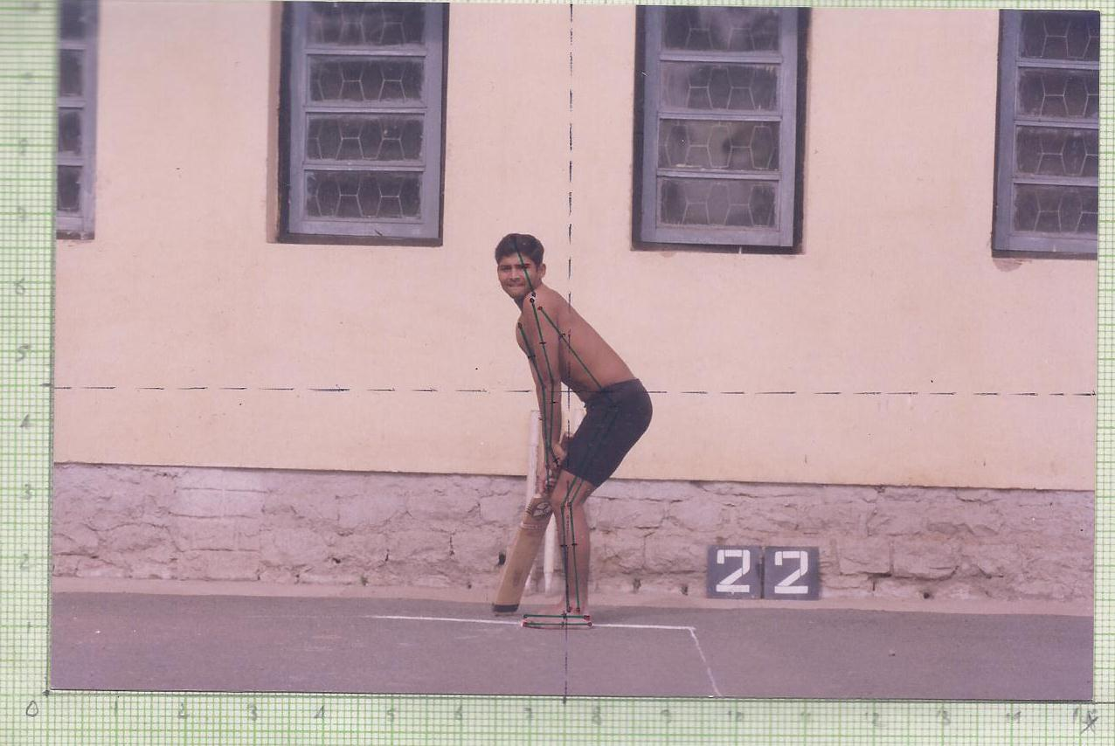
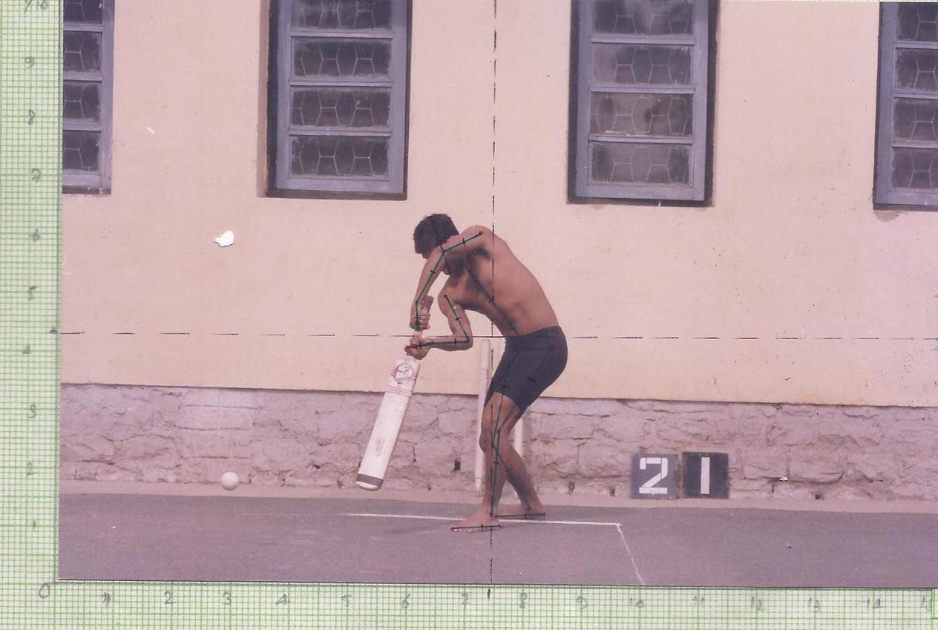
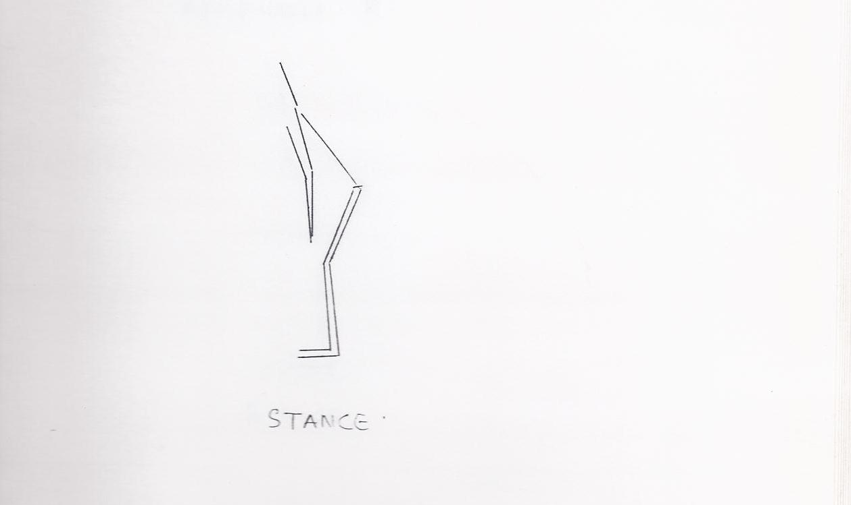
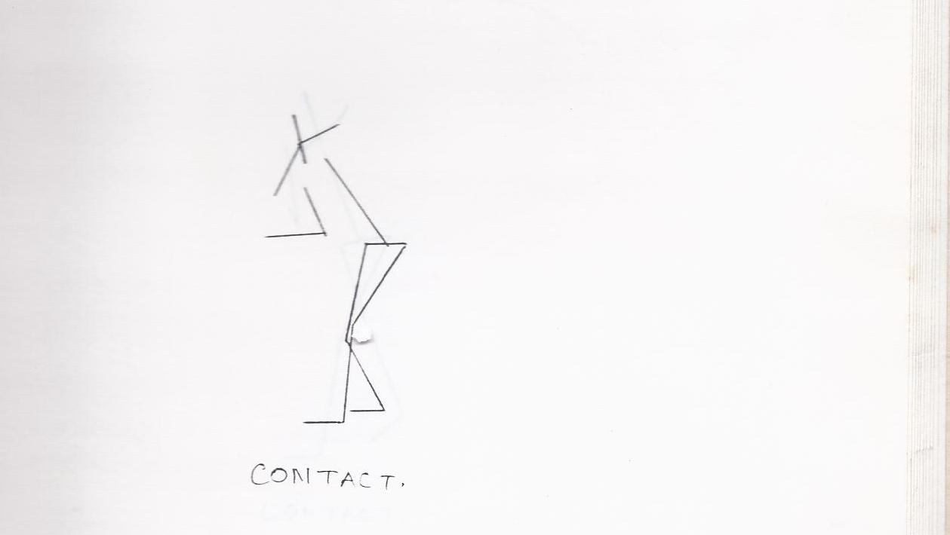

Photograph and Elegon of Various Moments of Subject 3

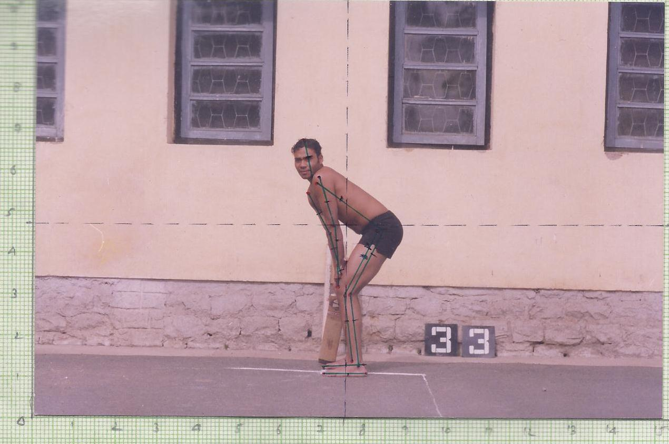
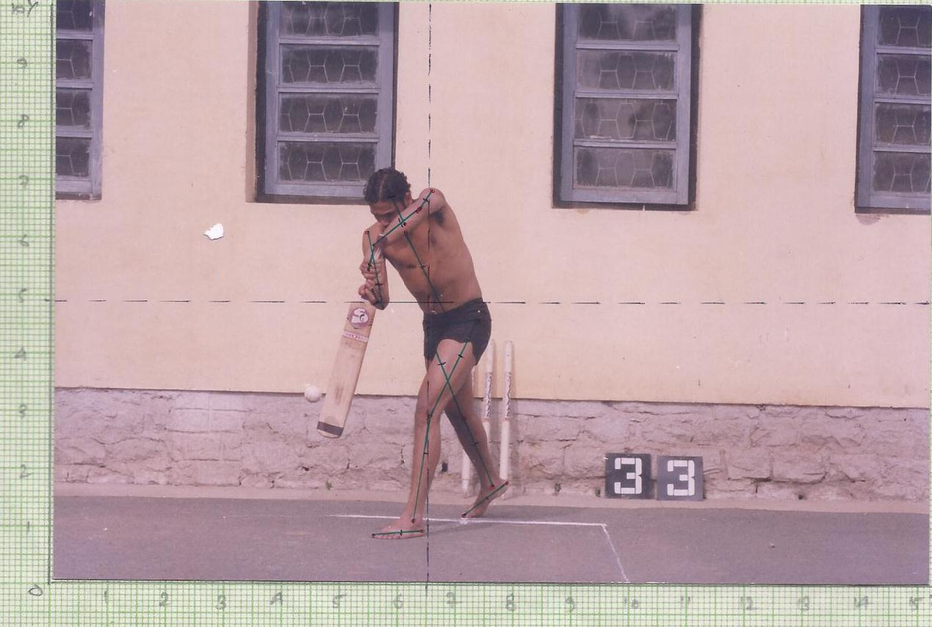
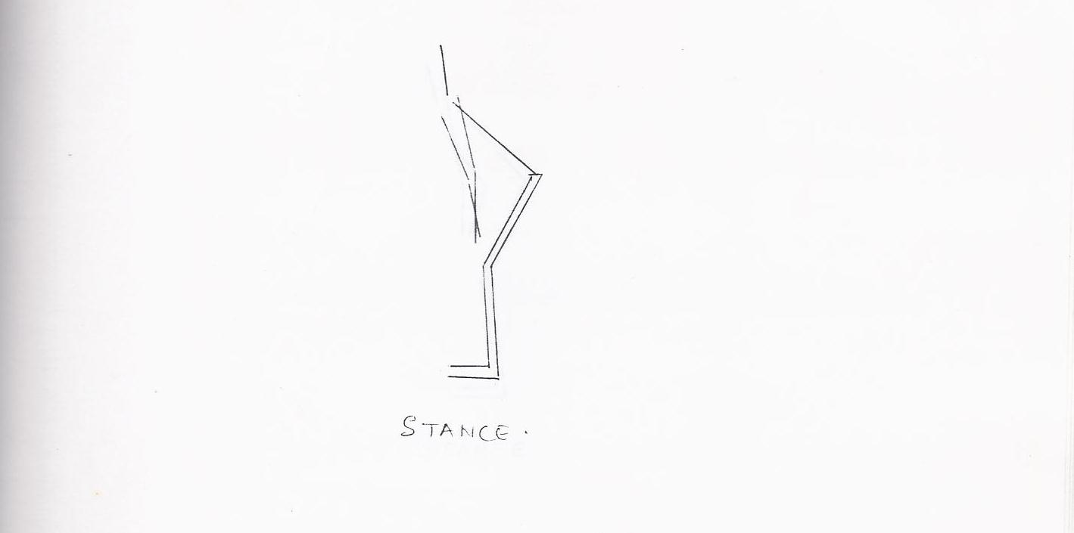
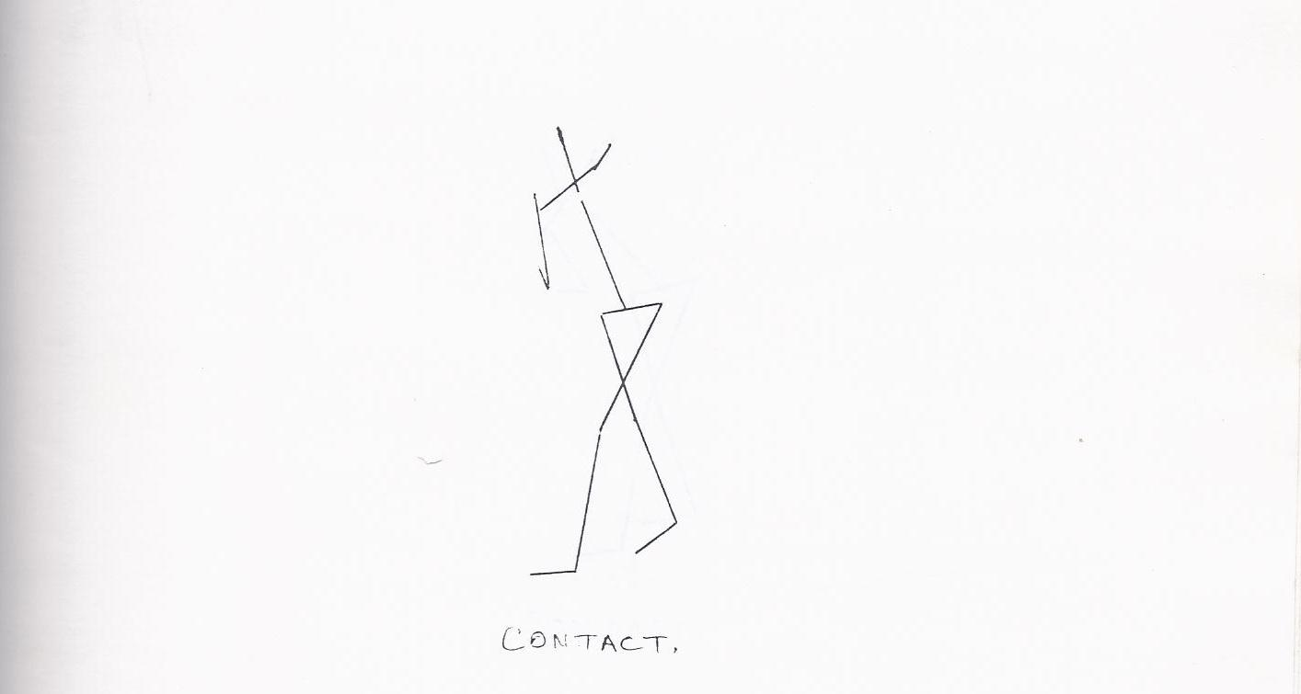

Photograph and Elegon of Various Moments of Subject 4

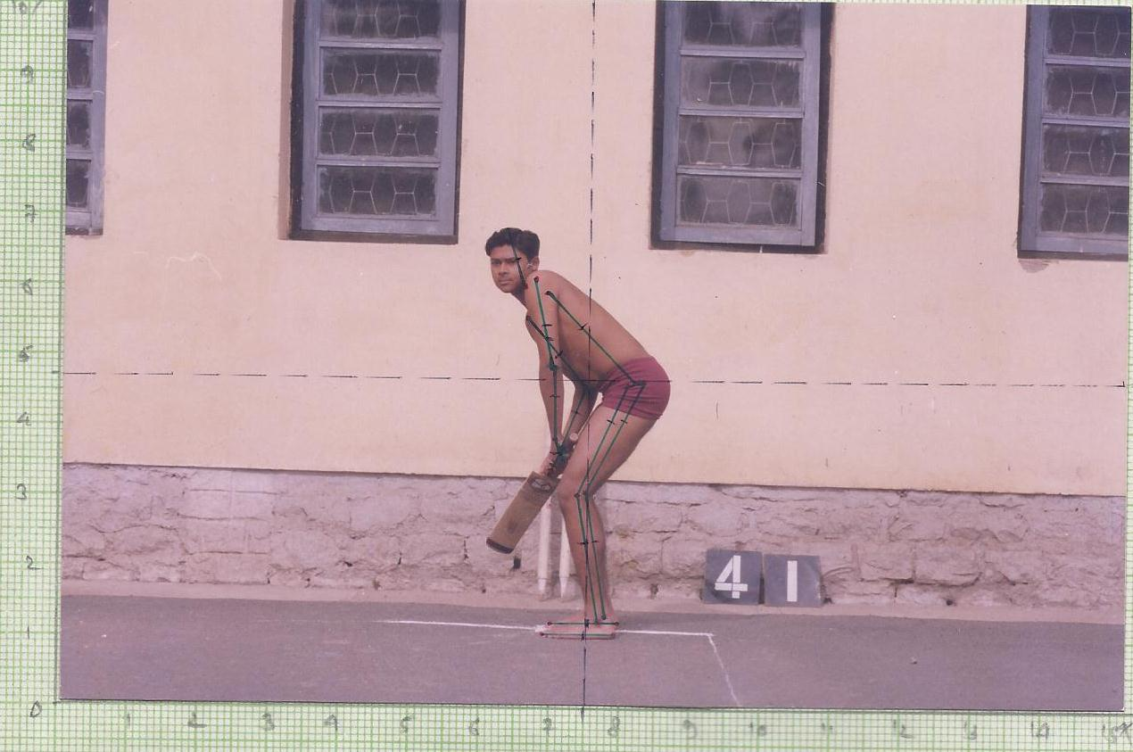
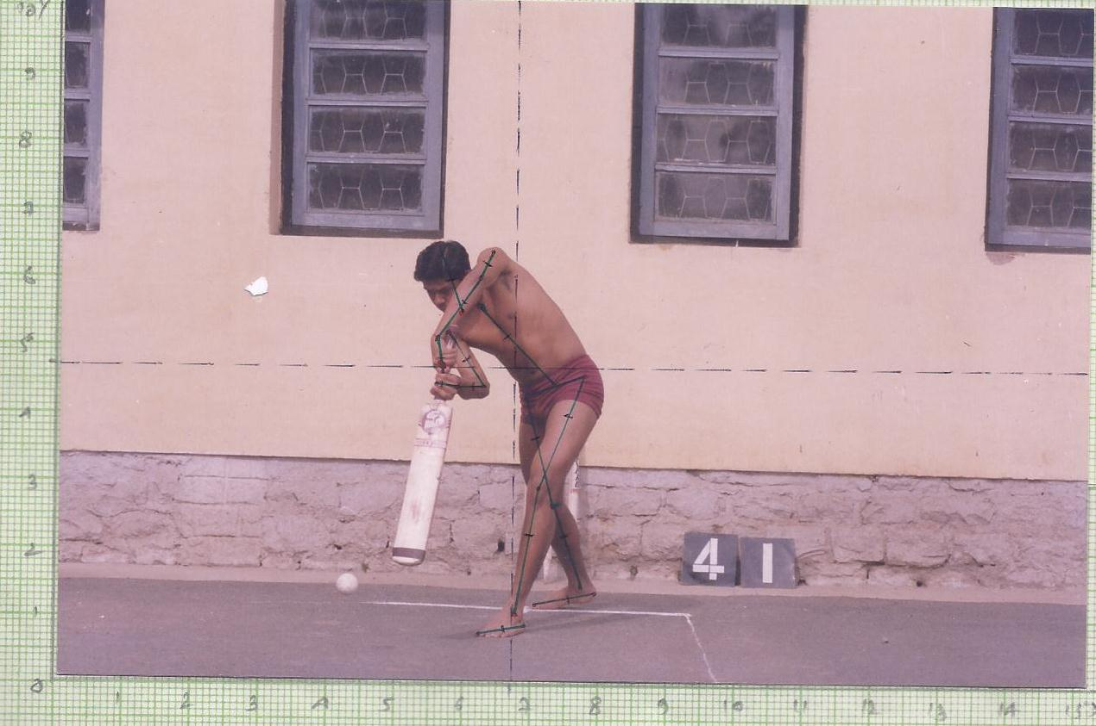
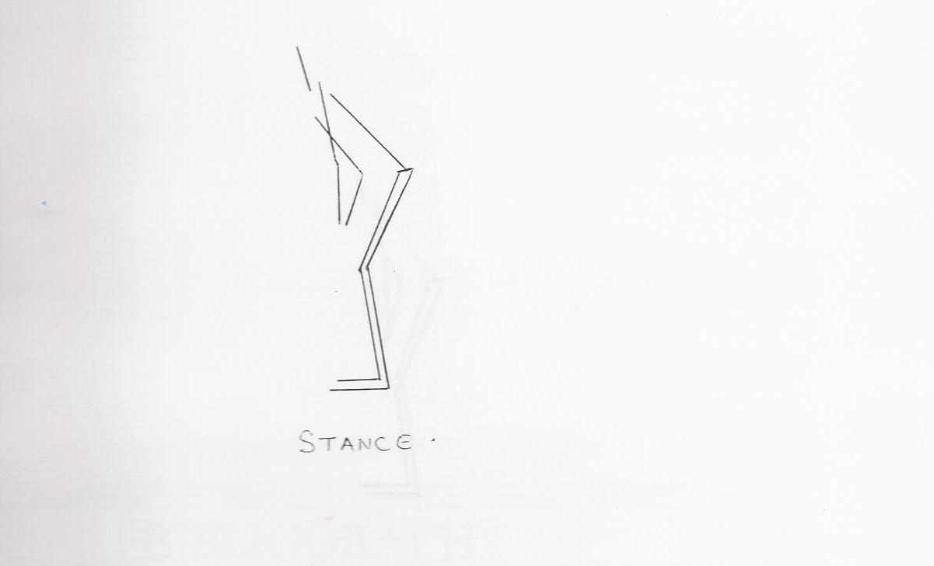
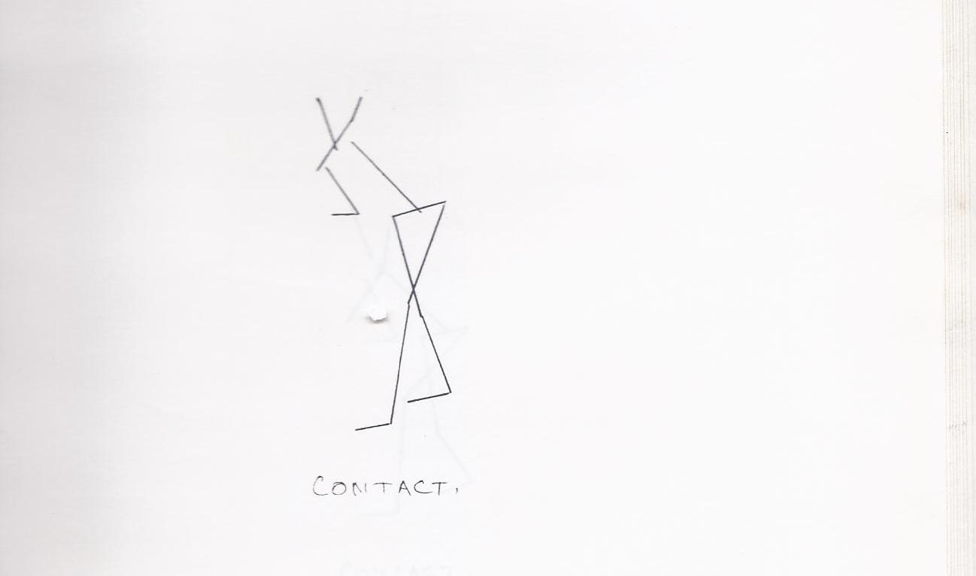

Photograph and Elegon of Various Moments of Subject 5

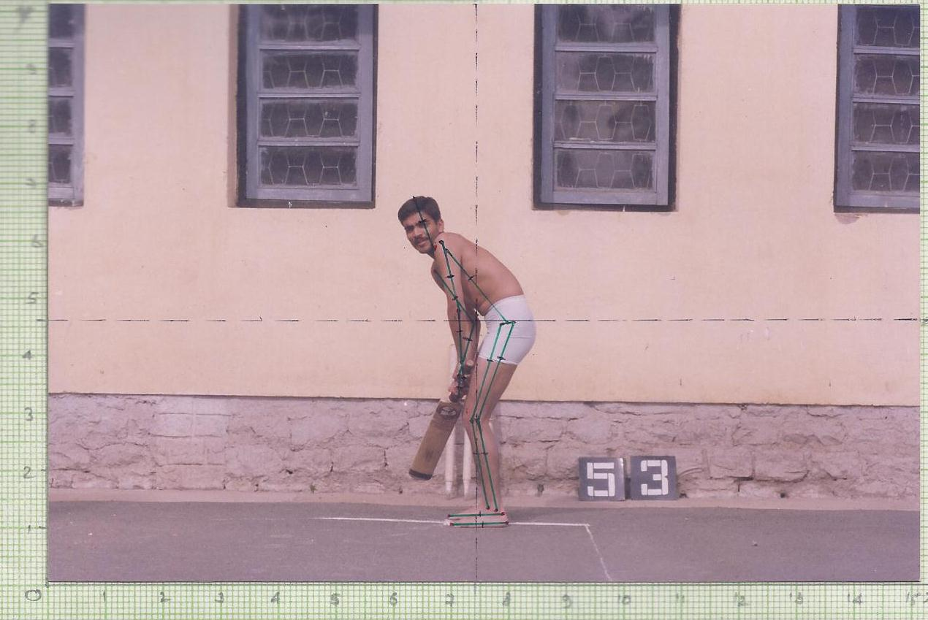
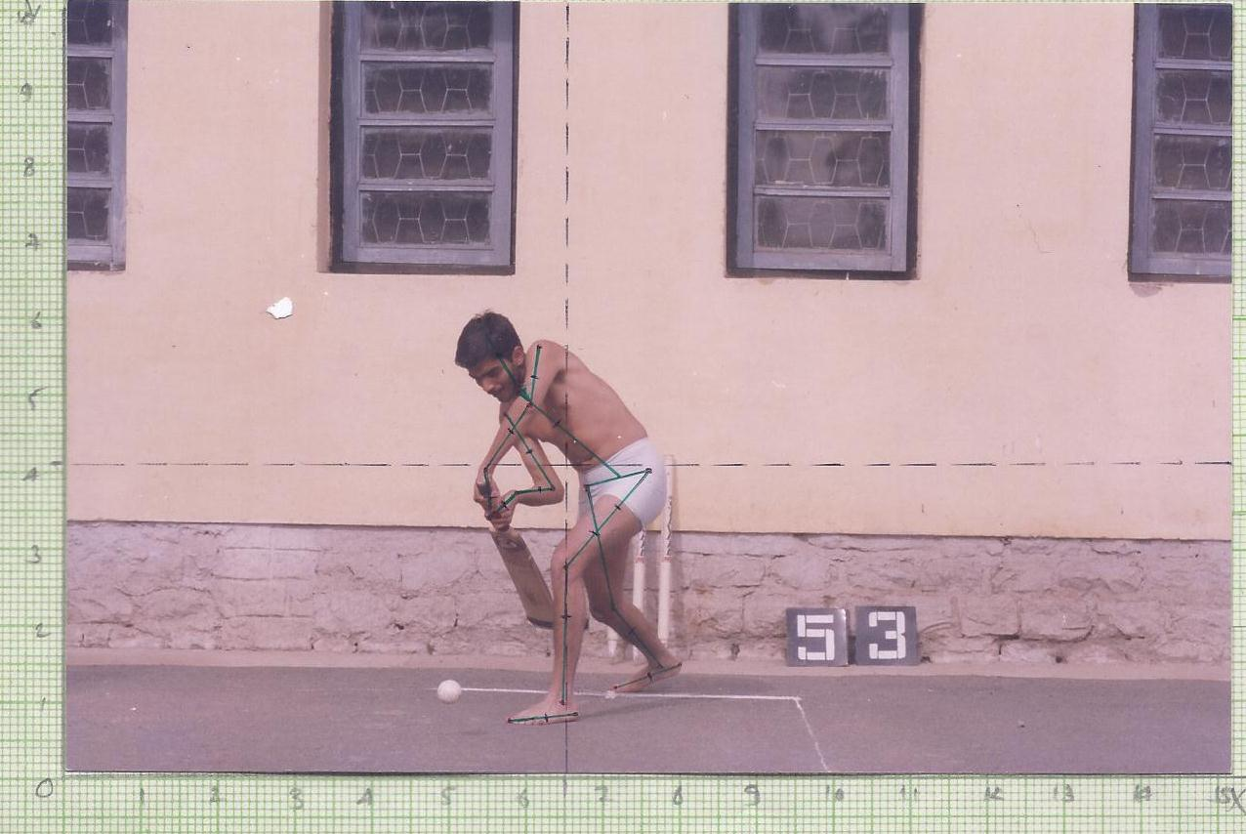
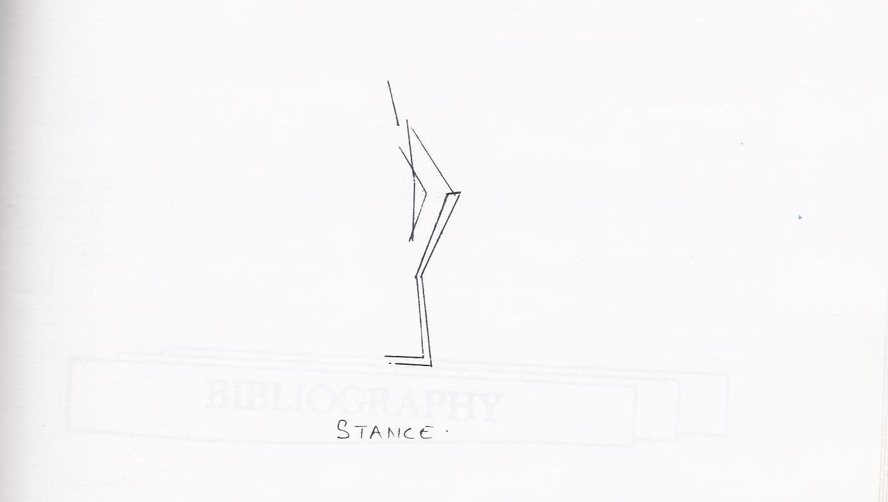
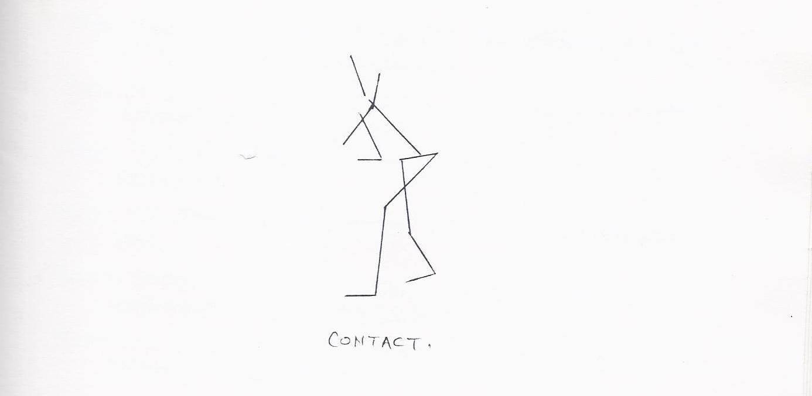

Result:

The relationship of selected angular kinematic variables with the performance of Front Foot Off drive in Cricket is presented in Table-3:

Table- 3
Means and coefficient of correlation of selected
Angular kinematic variables at the selected
Moments with the technique subjects in
Front foot off drive in cricket
Sl. No | ANGLES | STANCE  MEAN ‘r’ |  | CONTACT  MEAN ‘r’
1 | Ankle Joint (R) | 98 | 0.05 | 88 | -0.51
2 | Ankle Joint (L) | 95.4 | 0.59 | 117 | -0.39
3 | Knee Joint (R) | 151.8 | 0.09 | 159.2 | -0.64
4 | Knee Joint (L) | 148.6 | 0.24 | 157.2 | -0.02
5 | Hip Joint (R) | 124 | 0.96* | 93.2 | 0.95*
6 | Hip joint (L) | 123 | 0.96* | 132.6 | -0.51
7 | Shoulder Joint (R) | 23.6 | 0.2 | 18.4 | 0.47
8 | Shoulder Joint (L) | 29.8 | -0.26 | 85.4 | 0.24
9 | Elbow Joint (R) | 148.8 | 0.29 | 50.8 | 0.72
10 | Elbow Joint (L) | 166.6 | -0.49 | 138.0 | -0.02
* Significant at 0.05 level. r = 0.88

Since calculated value of ‘r’ for the right hip joint and left hip joint is higher than tabulated value of ‘r’ (=0.878), we accept the hypothesis. Thus correlation between angular kinematic variables of off drive with the batting technique of the subjects in cricket is significant at 0.05 level of significance.
The graphical representation of Relationship of Selected Kinematic Variables at Moment Stance with the Technique of Front Foot Off Drive in Cricket is presented in figure-1:

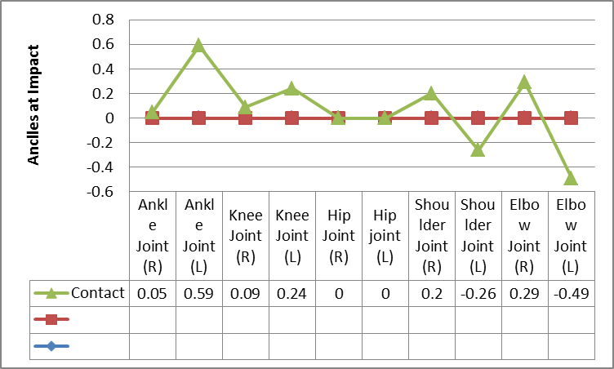
Figure-1: Relationship of selected angular kinematic variables at the moment stance with the technique subjects in front foot off drive in cricket

The graphical representation of Relationship of Selected Kinematic Variables at Moment Contact with the Technique of Front Foot Off Drive in Cricket is presented in figure-2:

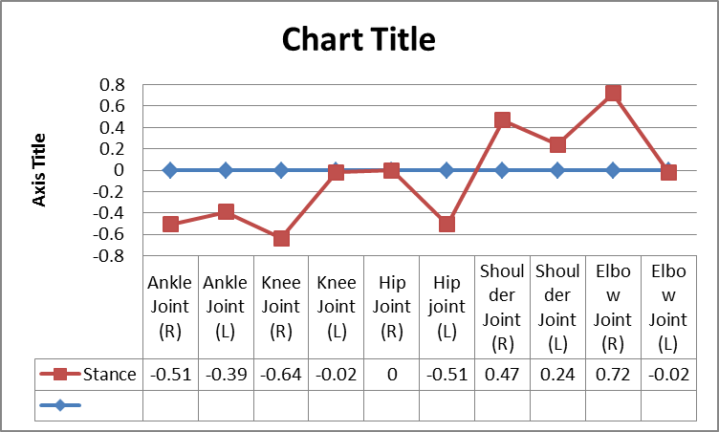
Figure-2: Relationship of selected angular kinematic variables at the moment contact with the technique
subjects in front foot off drive in cricket

The relationship of height of center of gravity at the moment Stance and Contact with the Technique of Front Foot Off Drive in batting in Cricket presented in Table-4

Table-4
Means and coefficient of correlation of selected
Linear kinematic variables at selected moments
with the technique of subjects Front
foot off drive in cricket
Variable | Stance |  | Contact
Height of  Centre of  Gravity | Mean | 'r' | Mean | 'r'
Height of  Centre of  Gravity | (Degree) |  | (Degree)
Height of  Centre of  Gravity | 92.4 | -0.75 | 95.5 | 0.25

The results of the Table-4 shows that at the height of centre of gravity at selected moments has insignificant relationship with the technique of subjects front foot off drive in cricket.

Discussion
In case of selected kinematic variables, none of the angular kinematic variables has exhibited significant relationship with the technique of subjects in Front Foot Off Drive. However at the moment stance and contact right hip joint and at the moment stance left hip joint showed a high and significant relationship with the technique of subjects in front foot Off-Drive. In angular kinematic Variables only three values of coefficient of correlation at selected moments were found significant but this trend does not mean that the angles at different joints at selected moments do not play any important role while executing Front Foot off-Drive. As in this study research Scholar have ascertained the relationship, individually at selected joints left and right side, their might be a significant relationship when we study their cumulative or upper body joints or lower body joints relationship with the technique of the subjects in the Front Foot Off- Drive.
The relationship of selected linear kinematic variable (Height of Centre of Gravity at selected moments) with the technique of the subjects at selected moments was found insignificant. As in the study the research scholar was only confined to the relationship of height of Centre of Gravity at selected moments with the technique of the subjects in the Front Foot Off- Drive but significant relationship may be obtained by studying the path or displacement of centre of gravity at selected moments. A significant result may also be obtained by increasing the sample size or by using the sophisticated equipments, like cinematographic techniques. On the whole, it may be ascertained that the variables which have shown high positive relationship with the technique of subjects in Front Foot Straight Drive along with these variables, other motor components also might have contributed to the technique of the subjects, in Front Foot Straight Drive. The low values of coefficient of correlation of these variables with the technique may be due to small sample size and non -availability of sophisticated equipments. Since, the results have shown insignificant relationship with the kinematic variables to the technique of subjects in the Front Foot Straight Drive, so the Hypothesis as stated earlier is not accepted in those variables.

Conclusions
Based on the analysis and within the limitations of the present study, following conclusions were drawn:
Angle at the Right Hip joint and Left Hip joint has shown positive relationship with the technique of subjects in Front Foot Off -Drive during the moment Stance and moment contact.

References

Hay, James G.( 1978) The Biomechanics of Sports Techniques. Englewood Cliff, N.J:PrenticeHall Inc. P: 112
Hochmuth, Gerald. (1984) Biomechanics of Athletic moment. Berlin: Sportverlog. P: 78
Johnson, Barry L.nad Nelson, Jack K. (1982), Practical Measurement for Evaluation in Physical Education. Delhi: Sujeet Publication. P: 54
Miller, Danis I and Nelson Richard C. (1973), Biomechanics of Sport. Philadelphia: Lea and Febiger.
Rash, Philips J. and Bucker, Roger K. (1978), Kinesiology and applied Anatomy. Philadelphia: Lea and Febiger. P: 99
Singh, Hardayal. ( 1991) Science of Sports Training. New Delhi D.V.S. Publication. P: 115
M. Sharhidd Taliep a;Ushma Galal b; Christopher L. Vaughan c . (2007)The Position of The Head and Centre of Mass During The Front Foot Off-Drive In Skilled and Less-Skilled Cricket Batsmen: P: 189
Müller S, Abernethy B (2006) Batting with occluded vision: an in situ examination of the information pick-up and interceptive Skill of high- and low- skilled cricket batsmen:. pp. 446-56
M.C.Stuelcken,M.R.Portus;B.R.Mason(2005), Off-side front foot drives in men's high performance cricket: published in: sports biomechanics. ,pp. 17-35
R.A. Stretch;G.N. Nurick;V. Balden; D.K. McKellar (2004) The position of impact of a ball striking a cricket bat :assisting coaches with performance analysis of cricket technique and skill levels: '' pp-74-81(8).

